Dear Colleagues,

Campus Operations is sequentially coordinating week 5 moves. Please see below for a list of completed moves to date.

Move priority date: Wednesday, June 12 – Tuesday, June 18
- Label plastic totes clearly

Next week look ahead – Monday, June 17
- DARS, Registrars and Sign Language Interpreters move to 1450 Midway Third Floor (illustrated in embedded map)
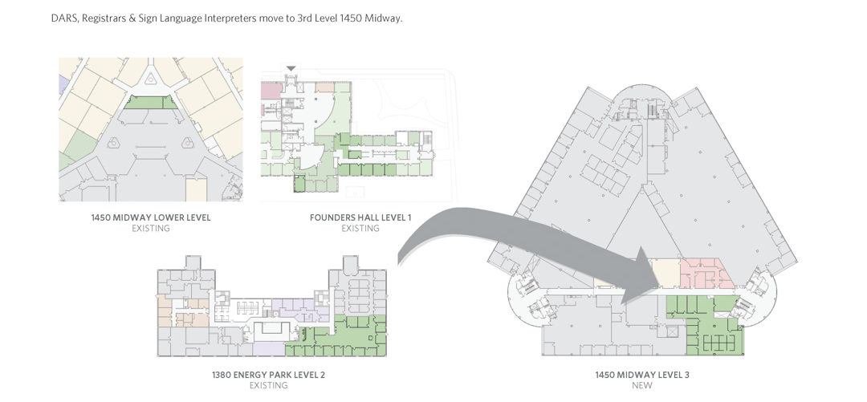

Space Move tips and resources:
- Areas preparing to move who might have walk-in student traffic during the time of the move should consider posting a plain, printed flyer in large, sans serif typeface giving: the date(s) of the unit’s move, the new location, and a contact number or email for a visitor to get more information
- Space Move Schedule
- Space Move FAQ

The progress made in the 2019 Space Move to date includes:
- College of Management vacated Management Education Center First Floor
- School of Urban Education vacated 1450 Midway Offices, and moved to Management Education Center First Floor
- CCSPA (Social Work, Human Services, Dean, Staff and Advisors) vacated St. John’s Hall Second Floor, and moved to 1450 Midway First Floor
- School of Communications, Writing, and the Arts vacated 1380 Energy Park Place Second Floor, and moved to St. John’s Hall Second Floor
- DARS moved to 1380 Energy Park STE 205 Second Floor temporary

If you have any concerns not covered by the FAQ or this message, email building.services@metrostate.edu.

Thank you again,
Building Services

