Dear Colleagues,

Campus Operations is sequentially coordinating week 4 moves. Please see below for a list of completed moves to date:

Move priority date: Wednesday, May 29 – Tuesday, June 4
- Label plastic totes clearly
- Reminder for tote return due this week at 10 a.m.
  - Monday, June 3 - SCWA

Next week look ahead – Monday, June 3
- DARS move to 1380 Energy Park STE 205 Second Floor temporary (illustrated in embedded map)
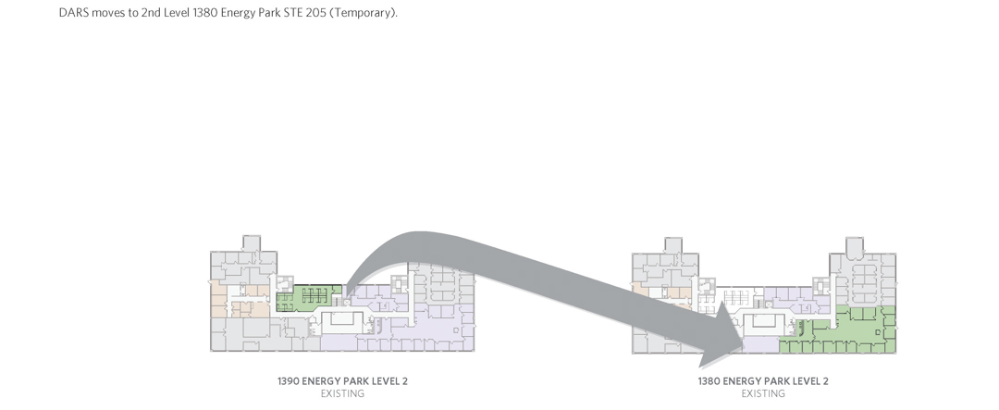

Space Move tips and resources:
- Areas preparing to move who might have walk-in student traffic during the time of the move should consider posting a plain, printed flyer in large, sans serif typeface giving: the date(s) of the unit’s move, the new location, and a contact number or email for a visitor to get more information
- Space Move Schedule
- Space Move FAQ

The progress made in the 2019 Space Move to date includes:
- College of Management vacated Management Education Center First Floor
- School of Urban Education vacated 1450 Midway Offices, and moved to Management Education Center First Floor
- CCSPA (Social Work, Human Services, Dean, Staff and Advisors) vacated St. John’s Hall Second Floor, and moved to 1450 Midway First Floor
- School of Communications, Writing, and the Arts vacated 1380 Energy Park Place Second Floor, and moved to St. John’s Hall Second Floor

If you have any concerns not covered by the FAQ or this message, email building.services@metrostate.edu.

Thank you again,
Building Services

