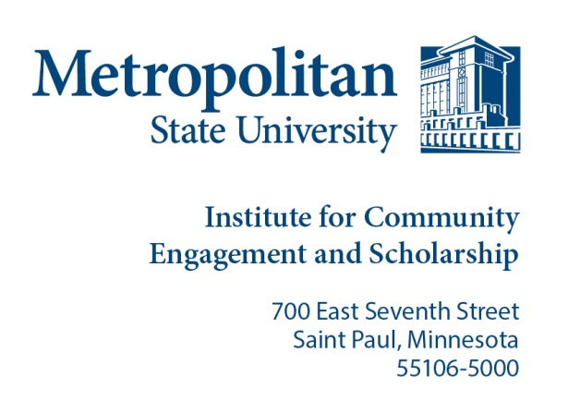
Project SHINE

Student Application

Applicant Information
Full Name: |  |  |  | Date:
 | Last | First

Date of birth: ___________ Gender: _______________ Ethnicity/Ethnicities: ______________

Languages spoken other than English: _______________

Address:
 | Street Address | Apartment/Unit #

 | City | State | ZIP Code

Phone: |  | Metro State Email | :

Student ID Number: |  | Total number of hours per week available for on-site tutoring:

Community Partner Choice: ________________________ (http://projectshinecommunitypartner.weebly.com/ to view community organizations, choose at least two sites for possible placement.)

Education Background

Anticipated Graduation Year: ________________________ Major(s):____________________________
Course No: Instructor: _______________________Number of Credits: __________
Highest level of education completed: ____________________

Do you have experience with ESL? _____________

If yes, explain below.

Have you participated in Project SHINE before?

Project SHINE experience:

TUTOR TRAINING: All tutors must attend a Project SHINE orientation/training session prior to placement. Please contact Awo Ahmed for the training date, time and location.

Will attend the training
No, I cannot attend the trainings.
Please send application to Awo Ahmed at awo.ahmed@metrostate.edu or call 651-793-1288 with any questions.

