Metropolitan State University’s

Spring Faculty Conference

Spaces of Belonging: Fostering an Inclusive Climate for Students, Faculty, and Staff
Please plan to join colleagues on March 16, 2019, 8:15 AM – 1:30 PM
In a moment when the politics of cruelty and the targeting of difference are having palpable effects in many of our lives and those of our students, how do we create spaces where all can develop a sense of belonging? Conversely, how do we intervene in “conspiracies of silence” that too often allow both structural and interpersonal marginalization and exclusion to go unchecked? Conference breakout sessions will explore our strategies, successes, and even failures as we collectively work toward Metro’s values of creating and maintaining an open, respectful, engaged, and inclusive climate for all.
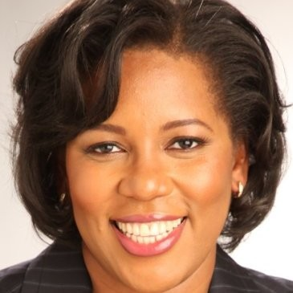

Keynote Speaker: Dr. Leah Hollis, Morgan State University
Author of Bully in the Ivory Tower: How Aggression and Incivility Erode American Higher Education
Dr. Leah Hollis is a healthy-workplace advocate whose work explores workplace bullying in higher education, particularly at the intersections of race, gender, LGBT identity and faculty rank. Dr. Hollis is a member of the faculty at Morgan State University in Baltimore, Maryland, where she teaches in the Community College Leadership Doctoral program. Dr. Hollis has worked with over 175 institutions, through workshops and webinars, keynotes, and consultations on workplace bullying in higher education.
To register for the conference, go to:
ttps://www.surveymonkey.com/r/FJXFK33

Registration will remain open until March 12, 2019.

