Dear Colleagues,

The 2019 Space Moves have begun. Campus Operations is sequentially coordinating unit moves to minimize the inevitable disruption to our standard work routine, while enabling us to be prepared and student-centered come fall semester. Please see below for a list of completed moves to date.

**Move priority date: Wednesday, May 8 – Tuesday, May 14**

* Faculty who are affected by the move and are going off-contract should have their offices packed for the move and their office keys turned in to their office administrators by **May 10**
* Allotted storage boxes and plastic totes have been distributed per the rental agreement form
* Please take personal items home before the move

**Next week look ahead – Monday, May 13**

* School of Urban Education vacates 1450 Midway Offices, and moves to Management Education Center First Floor (illustrated in embedded map)

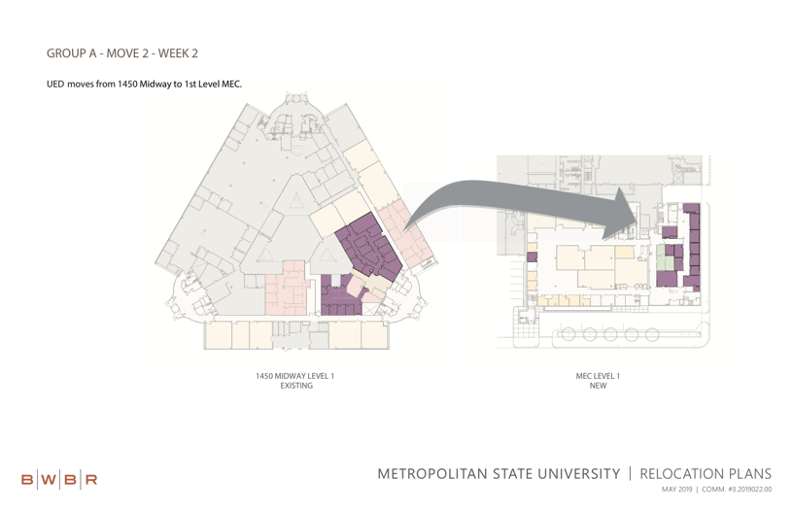

**Space Move tips and resources:**

* Areas preparing to move who might have walk-in student traffic during the time of the move should consider posting a plain, printed flyer in large, sans serif typeface giving: the date(s) of the unit’s move, the new location, and a contact number or email for a visitor to get more information
* [Space Move FAQ](https://services.metrostate.edu/TDClient/KB/ArticleDet?ID=76068¬)

**The progress made in the 2019 Space Move to date includes:**

* College of Management vacated Management Education Center First Floor

If you have any concerns not covered by the FAQs or this message, email [building.services@metrostate.edu](mailto:building.services@metrostate.edu).

Thank you again,

Building Services