Dear Colleagues,

Campus Operations is sequentially coordinating week 2 moves. Please see below for a list of completed moves to date:

**Move priority date: Wednesday, May 15 – Tuesday, May 21**

* Label boxes/plastic totes clearly
* Collect old keys from College of Community Studies and Public Affairs (CCSPA) staff and faculty

**Next week look ahead – Monday, May 20**

* CCSPA (Social Work, Human Services, Dean, Staff and Advisors) vacates St. John’s Hall Second Floor, and moves to 1450 Midway First Floor (illustrated in embedded map)

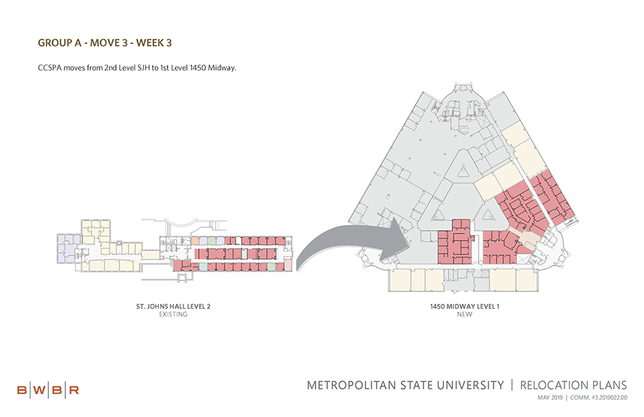

**Space Move tips and resources:**

* Areas preparing to move who might have walk-in student traffic during the time of the move should consider posting a plain, printed flyer in large, sans serif typeface giving: the date(s) of the unit’s move, the new location, and a contact number or email for a visitor to get more information
* [Space Move Schedule](https://www.metrostate.edu/about/president/university-space-moves)
* [Space Move FAQ](https://services.metrostate.edu/TDClient/KB/ArticleDet?ID=76068)

**The progress made in the 2019 Space Move to date includes:**

* College of Management vacated Management Education Ce­­­nter First Floor
* School of Urban Education vacates 1450 Midway Offices, and moves to Management Education Center First Floor

If you have any concerns not covered by the FAQ or this message, email [building.services@metrostate.edu](mailto:building.services@metrostate.edu).

Thank you again,

Building Services