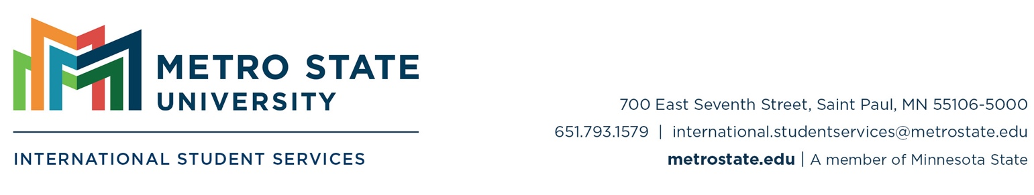

Financial Letter of Support
Use this template for non-U.S. citizen/permanent resident, written in English, indicating their willingness to support your financial obligations.

The letter must:
- Be dated within the last 6 months;
- Include the sponsor’s original signature;
- Include full name of the individual sponsoring the student;
- Include the full name of the student being sponsored;
- Include a statement that the individual is willing to sponsor the student for a specified amount and specified duration of time; and
- Should include the relationship of the student to the sponsor (i.e. sibling, friend, spouse, etc.)

Letter Template
Date
Sponsor’s Name
Sponsor’s Street Address
Sponsor’s City, State/Province/Region (if applicable), and Postal Code
Sponsor’s Country of Residence
RE: Sponsorship letter for Student’s Name
To Whom it May Concern:
This letter is to verify that I, Sponsor’s Name, am willing and capable of financially supporting my Relationship to Student, Student’s Name, as a student at Metro State University. I have provided personal financial documentation to show that I have sufficient funds to support Student’s Name for U.S. $ [sponsor’s financial contribution] for [duration of sponsorship].
If you have any questions or concerns about this matter, please feel free to contact me at Sponsor’s Email Address and/or Phone Number.
Sincerely,
Sponsor’s Original Signature
Sponsor’s Name
This document is available in alternative formats upon request, by contacting the Center for Accessibility Resources, Accessibility.Resources@metrostate.edu or 651.793.1549.

