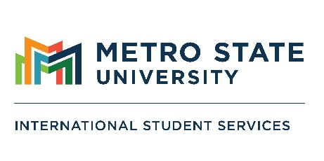

International Student Orientation

Wednesday, August 19, 2026
9:00 a.m. – 4:30 p.m.
St. Paul Campus, Student Center 101

Time | Presentation
9:00 a.m. – 9:30 a.m. | Introduction to ISS and Metro State (Student Center 101)  - Kristy Nelson Ramos, Director of International Student Services  **Fruit, pastries, coffee, and water will be provided**
9:45 a.m. – 11:00 a.m. | Library and Information Services (Library and Learning Center)  - Robin Gee, Student Success Librarian
11:00 a.m. – 11:30 a.m. | Tutoring and Writing Center (Library and Learning Center, Room 219)  - Luke Morgan, Director of Writing Center
11:30 a.m. – 12:00 p.m. | Career Center (Library and Learning Center, Room 156)  - Kate Larson, Career Counselor  - Susan Hang, Internship & Apprenticeship Coordinator
12:00 p.m. – 1:30 p.m. | Lunch and Social Activities (Student Center 101) and Intro to MAIR  **Lunch will be provided**
1:30 p.m. – 1:45 p.m. | Student Health and Basic Needs (Student Center, Student Parent Center)  - Katie Peterson, Student Parent Coordinator
1:45 p.m. – 2:00 p.m. | Student Life and Development (Student Center, Room 204)  - Tonia Baxter, New Student Orientation and First Year Experience Coordinator
2:15 p.m. – 2:30 p.m. | Gateway (Founders Hall, 1st floor)  - Rachel Hanson, Associate Director, Gateway Student Services
2:45 p.m. – 3:15 p.m. | STEM+ Center (Jason R. Carter Science Education Center, Room 122)  - Ben Hamilton, Director of STEM+ Tutoring
3:30 p.m. – 4:30 p.m. | Maintaining F-1 Status, International Student Health Insurance (Student Center 101)  - Kristy Nelson Ramos, Director of International Student Services  Contact us  international.studentservices@ metrostate.edu  651.793.1316  Don’t forget to Check-In!  metrostate.edu/students/support/international/ orientation
