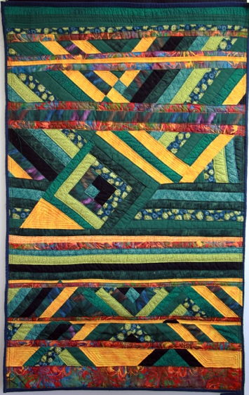

**Art Purchase Award**

**Entry Form**

**Due: April 1, 2018**

**Due: April 1, 2015M**

2017 purchase: Halle O’Falvey, *Abstract Log Cabin*, cotton fabric and thread, 2017

**Personal Information**

name: .

address: .

city: state: zip code: .

phone number: .

e-mail: .

student/alumni/faculty (circle one)

The AEC will be reviewing digital images (300 dpi jpgs, 4 x 6” preferred, less than 1 MB each). If you don’t have access to a digital camera, make an appointment to bring the work to Amy Sands’ Midway EPP office for documentation.

Winning artists will be responsible for display supports (i.e. two-dimensional works should be properly framed and sculptural objects should be equipped with secure bases).

Please return a scan of this application and numbered images to Prof. Amy Sands at Amy.Sands@metrostate.edu.

**I agree to the terms and conditions of the competition. I also agree to allow the submitted artwork to be reproduced for educational or promotional purposes, free of further compensation.**

X_______________________________________________________(signature) ________________________(date)

**applicant’s signature date .**

over **→**

over